E-Vetting– A Step By Step Guide

- If you are Over 18:
  - Print & Complete the E-Vetting ID form. Scan or take a Photo of it.
  - Scan or take a Photo of your Passport OR Driving Licence (new credit card format only) AND
  - Scan or take a Photo of a recent utility bill OR bank/credit card statement confirming your name and address.
- If you are aged between 16 and 18:
  - Print & Complete the E-Vetting ID form. Scan or take a Photo of it.
  - Print and obtain completed Parental Consent Form. Scan or take a Photo of it.
  - Scan or take a Photo of your Passport OR Birth Certificate OR Student Photographic Identity Card
- Proof of ID to be provided to the club: FORWARD a copy of the documents you created in step 1 or 2 to the club children’s officer or other nominated club official. (via email/ in person)
- You will also need the following information for later:-
  - Date of Birth
  - Place of Birth
  - Mother’s Maiden Name
  - Passport Number where applicable
  - Job Role (in your club), i.e. Mentor
  - Your current address and previous addresses (if any)
  - Particulars of any criminal record
- Click here to Request a Vetting Application Form. Complete the required details and Submit. Provided you have the documents referred to in Step 1 or 2 above, answer “Yes” to the 2 questions shown below. You MUST then complete Step 6 very promptly.
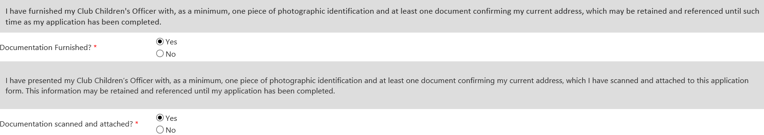
- You will shortly receive an email confirming receipt of your Application Form Request.
- Soon afterwards you will receive an email to Access your Vetting Application. You have 30 days to complete your Application.
- Complete your Vetting Application and Submit.
- You will shortly receive an email confirming receipt of your Vetting Application. You will then receive ongoing tracking updates until your vetting is completed.
- Within a few days, you should receive your Vetting Acceptance notification email which contains your Vetting Acceptance letter from the GAA in PDF format.
- This GAA Garda Vetting Acceptance notification is also automatically forwarded to the Club Secretary, and no further action is required on your part.

Useful Links:-
Vetting in the GAA http://www.gaa.ie/the-gaa/child-welfare-and-protection/vetting
FAQ from Garda https://vetting.garda.ie/Help/FAQ

