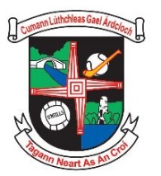

**Nominations for Football Committee 2023/24**

|  |  |  |  |  |
| --- | --- | --- | --- | --- |
| **Oifig / Position:** | **Office Holder 2022/23** | **Person Nominated** | **Proposed By** | **Seconded By** |
| Cathaoirleach / Chairperson Football Club | Larry Graham |  |  |  |
| **An Rúnaí /** Secretary Football Committee | Brian Mullen |  |  |  |
| **Committee Member 1** | John McGreal |  |  |  |
| **Committee Member 2** | Martin Bambrick |  |  |  |
| **Committee Member 3** | Gary Finneran |  |  |  |
| **Committee Member 4** | Barry Molloy |  |  |  |
| **Committee Member 5** | Des Byrne |  |  |  |
| **Committee Member 6** | Marcus Byrne |  |  |  |

***Must be returned on, or before, 12th November 2023***

*Can be placed in a box behind the bar or emailed to* [*secretary.ardclough.kildare@gaa.ie*](mailto:secretary.ardclough.kildare@gaa.ie)